EPS207 Computer Laboratory 0 – The Berkeley Digital Seismic Network, data acquisition and processing

Introduction

The objective of this exercise is to become familiar with the data resources of the Berkeley Digital Seismic Network (BDSN), Northern California Earthquake Data Center (NCEDC), the Seismic Analysis Code (SAC) package and basic data manipulation that will be required in subsequent labs.

Students associated with the Berkeley Seismological Laboratory (BSL) should use their research computer accounts. Students not associated with the BSL will be provided computer accounts on the server (atlas.geo.berkeley.edu). Use ssh to log on to the server. You will be prompted for a user name and password, which will be emailed to you. After you successfully log on you should see the atlas command prompt (atlas%). Our computer system runs the Solaris operating system and familiarity with UNIX and the Solaris variants is necessary for this and subsequent exercises. Some initial setup is also required:

- Change program path. To change the program path use the “textedit” program to modify the ‘set lpath = ( )’ line to ‘set lpath = (/data/04/dreger/Bin)’ in the .cshrc file (i.e. atlas%textedit .cshrc). After doing this type “source .cshrc” This only has to be done the first time you login.

Berkeley Digital Seismic Network

The Berkeley Seismological Laboratory operates a network of about 20 broadband, high dynamic range, digital stations that consist of collocated weak motion velocity, strong motion acceleration sensors and GPS. The seismic instrumentation provide on-scale recording of earth ground motions from background noise to the dynamic motions of a nearby magnitude 8 earthquake. These data are digital and continuously telemetered to the NCEDC in near-realtime (~28 s), and available to the research community in a similar time frame. Figure 1 is a map of the BDSN. Additional information on the operation of the BDSN may be found at the Berkeley Seismological Laboratory webpage:

1. http://www.seismo.berkeley.edu/seismo/Homepage.html. Follow the “Overview” link.

The NCEDC web page provides access to earthquake catalog information, BDSN waveforms and Northern California Seismic Network waveforms and phase information. The location of the NCEDC page is:

2. http://quake.geo.berkeley.edu

Take time to review the general information on the website. Northern California hypocenter information can be obtained by following the ‘Data access’ and clicking on the appropriate link under the Earthquake Catalogs section. Use the web-form to obtain epicentral information for a M3.45 San Jose earthquake, which occurred on January 17, 2000. You will need to make a note of the origin time and location (latitude and longitude).

Data Access

Waveform data may be obtained by using the ‘qdata’ command from your user accounts. To use qdata you will need to decide on a start time for the data request. I find that truncating the origin time to the minute usually provides a good start time. For example if the origin time of the earthquake is 23:32:55(UTC) a start time of 23:32:0.0 would be a good choice. The day of the year (doy) is also required input, and is obvious for events in the month of January. For all other months the dyr program is useful. Usage is as follows:

dyr 01 17 2000

Data may be obtained from the qdata command, the format of which follows

qdata –f year.doy,hr:mn:sec –s record_duration station_list.network_code.component_stream

For the San Jose event use:

swc -S ncedc_archive –f 2000.017,23:32:0.0 –s 5M ‘MHC.BK.HL?.*’

The command line above returns three files one for each component (E, N, Z) of 80 samples per second acceleration for station MHC. The record length of each file is 5 minutes. If you wanted 5 minutes of broadband velocity you can substitute BH for HL. If you want data from all of the BDSN stations you can substitute “\*” for “MHC”. For the remainder of the exercise we will use the acceleration data recorded at MHC obtained using the command above.

The data files must now be translated to SAC format. This is done by the following command, which reads the MHC.BK.HLE..D.2000.017.233200 file and writes the 20000117233200.MHC.HLE SAC file:

ms2sac MHC.BK.HLE..D.2000.017.233200 > 20000117233200.MHC.HLE

This command needs to be repeated for each component. The output filename convention is ‘yearmodyhrmnsc.station.stream_component ‘.

We now have SAC files of ground motion data viewed through an instrument filter. It is a straight forward process to remove the instrument filter. The BSL maintains a file of instrument responses that can be accessed using the get_resp program. The usage follows:

get_resp name=station name comp=component_stream date=year.doy

For the San Jose event use:

get_resp name=MHC comp=ELG_ date=2000.017

This will need to be repeated for each component. Note if you collected the broadband velocity data using the BH stream above then you would need to substitute EVBB for ELG_ on the get_resp command line. The get_resp command above returns a zero-pole file MHC_ELG_.zp that contains the instrument gain, instrument zeros and instrument poles (clarification in a moment).

Note on Reducing Key Strokes.

You will need to run the ms2sac and get_resp commands for each component. The foreach command can expedite the processing by looping over a defined variable. For example:

foreach n (E N Z)
ms2sac MHC.BK.HL{$n}..D.2000.017.2332 > 20000117233200.MHC.HL{$n}
get_resp name=MHC comp={$n}LG_ date=2000.017
end

will process the three-component waveform data and collect the required instrument response files. It is possible to nest the foreach loops and when you are processing multiple stations it is a real time saver.

Note on Instrument Response.

For the example above the get_resp command returns an ascii file called MHC_ELG_.zp. This file contains a zero-pole representation of the instrument response, which can be used to remove the response using SAC. The response file contains a gain constant, zeros and poles that describe the response. This format is very compact, and can be easily shown to represent the response in the frequency domain. E.g. for a simple pendulum seismometer, the seismometer output, U(t), is related to the input acceleration (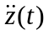) by the indicator equation, where A is the gain, is the damping factor, and 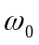 is the resonance frequency of the instrument.

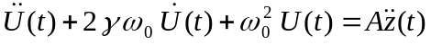

By taking the Fourier transform of the indicator equation a 2nd order polynomial equation is found relating the instrument output acceleration spectrum, 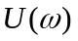, to the input acceleration spectrum, 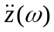.

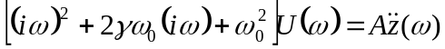

Solving for results in a response function that can be characterized by a gain constant A, the product of zeros (there are no zeros in this case), and the product of poles, which are equal to 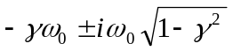.

U(ω)=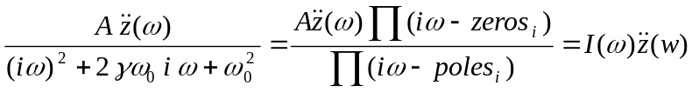

Ground acceleration may be found from

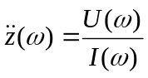.

SAC

This section will introduce the SAC program, which is a comprehensive time series analysis package that we will use extensively throughout the course. In this exercise we will use SAC to remove the instrument response, produce ground velocity and displacement seismograms by integrating the input acceleration, and filter noise from the displacement data. A complete reference to SAC is available at
http://www.llnl.gov/sac/.

To get started, at the atlas prompt execute the command ‘sac’. You should now see a SAC prompt (SAC>) where you can enter the SAC commands.

First read in the data, add hypocentral information, and write over.

SAC>qdp off quick and dirty plot off
SAC>read 20000117233200.MHC.HL* read file(s)
SAC>ch evla 37.367 evlo –121.731 change header
SAC>lh dist az list distance and azimuth header information
SAC>write over write data in memory to input filenames (dangerous)

Second, read each component separately and remove the mean and the instrument response (returns ground acceleration in units of m/s/s), write to new files.

SAC>read 20000117233200.MHC.HLE
SAC>p1 plot (creates an x-window in this instance)
SAC>rmean remove mean
SAC>transfer from polezero s MHC_ELG_.zp remove instrument response (output units will be m/s/s)
SAC>p1
SAC>write mhcacc.e write to file(s)

Etc.

Third, read the horizontal components, rotate to radial and transverse components, and write to new files.

SAC>read mhcacc.[e,n]
SAC>cut 50 68 set cut limits to truncate data as it is read (units s)

SAC> rot to gcp rotate to Great-Circle-Path (other usage rot to angle(deg)
SAC>write mhcacc.r mhcacc.t

Forth read the rotated data files and make three plots for acceleration, velocity and displacement.

SAC>read mhcacc.[r,t,z]
SAC>xlim 50 70 change limits of x (time) axis (units s)
SAC>bd sgf begin Sac-Graphics-File device (for output) Note that when you use this command all output that would ordinarily go to the x-plot window using p1 will be written to a file. To return to x-window plotting without quiting SAC use the bd x command.
SAC>p1
SAC>int integrate data (time domain)
SAC>p1
SAC>int
SAC>p1
SAC>quit leave SAC

There are now three new files called f001.sgf, f002.sgf, and f003.sgf. Use the sgftops command to write the sac graphics files to postscript for printing.

sgftops f001.sgf f001.ps etc.

You will notice that there is long-period noise in the displacement data. This can be removed using a variety of filters available in SAC. Try to remove the trend by applying a high pass filter with a corner of 0.05 Hz.

SAC>read mhcacc.[r,t,z]
SAC>rmean
SAC>int
SAC>int
SAC>p1
SAC>hp co 0.05 p 2 high pass filter with a corner of 0.05 Hz and 2 passes (acausal). Note options include p 1 (causal) and bp (bandpass) and lp (low pass).
SAC>p1

Finally, use SAC to prepare plots of the acceleration amplitude spectrum for the transverse component. To do this you will find the fft and writesp commands useful. Before you perform the fft be sure to use the ‘cut 40 68’ command to truncate the time series.

If there are any questions regarding these initial exercises please contact me via email.

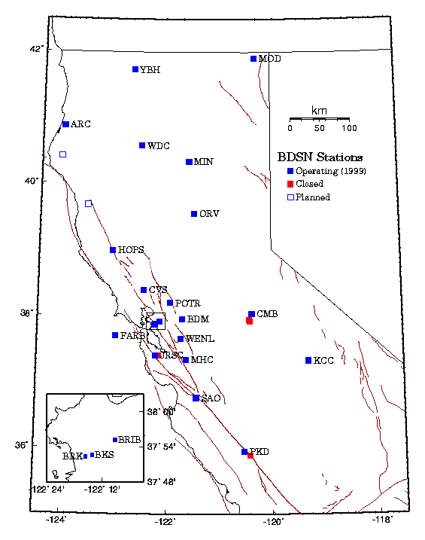
Figure 1. Map of the BDSN showing the current configuration of the network. Each of these sites have both broadband velocity and strong motion acceleration recorders.

